Function requirement 1

Description:

Record data about the patient to enjoy the features of the system and ease of communication.

Input

Name , phone ,address ,email, date of entry ,date of exit, name of Guardian, phone of Guardian , Patient history .

Processing

Take information and save it.

Output

Registration the patient on the system.

Function requirement 2

Description:

Book an appointment with a specialist doctor or cancel.

Input

Book or cancel

Processing

Back to the doctor's appointments, then look if it is possible to book or cancel

Output

Inform the doctor of the appointment or cancel.

Function requirement 3

Description:

Modify or delete some patient data

Input

Select data and select modify or delete it

Processing

Execute modification based on new data or delete it

Output

Update new data.

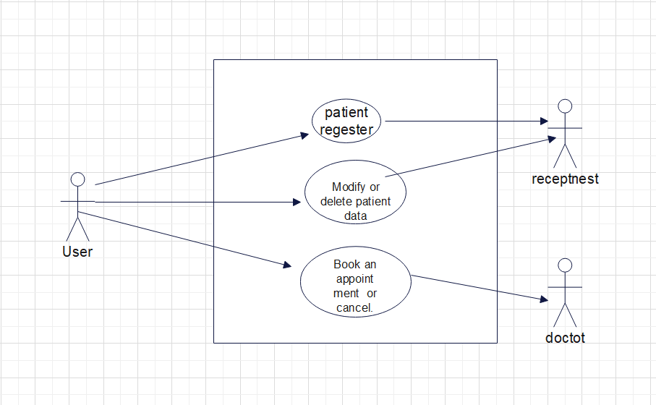

|  |  |
| --- | --- |
| Use case id | 1 |
| Use case name | Patient register |
| Actors | Patient and receptionist |
| Precondition | Payment of fees |
| Flow of event | 1. Entering the site. 2. Go to the login page. 3. Enter the correct data |
| Postcondtion | Book an appointment with a specialist doctor |

|  |  |
| --- | --- |
| Use case id | 2 |
| Use case name | Book or cancel an appointment with doctor |
| Actors | Patient and doctor |
| Precondition | Sign in system |
| Flow of event | 1. Choosing a specialty. 2. Choosing a doctor 3. Choose the date from the available dates. 4. Appointment Confirmation |
| Postcondtion | Receive a notification |

|  |  |
| --- | --- |
| Use case id | 3 |
| Use case name | Modify or delete patient data |
| Actors | Patient |
| Precondition | Sign up |
| Flow of event | 1. Go to Settings 2. .Select Edit Personal Data 3. .Edit data 4. .Save |
| Postcondtion | Receive a notification |